**Daniel and the Lions**

**Reading: From Daniel chapter 6**

The king was impressed with Daniel and planned to make him ruler over the whole kingdom. But the other supervisors were very jealous. They tried to find reasons to accuse Daniel. But he did not cheat the king, and he worked very hard.

The supervisors went to the king. They said, “We think that the king should make this law; for the next 30 days, whoever prays to any God except you, King, will be thrown into the lions’ den.” So King Darious made the law and signed it.

Daniel always prayed to God three times every day. Even though he heard about the new law, he still went to his house to pray.

The supervisors went to the king and said, “Daniel still prays to his God three times a day.”

The king became very sad and upset when he heard this. They brought Daniel and threw him into the lions’ den. The king said to Daniel, “May the God you serve save you!”

The next morning King Darius ran to the lions’ den. He called to Daniel, “Daniel has your God been able to save you from the lions?”

Daniel answered, “My God sent his angel to save me. The angel closed the lions’ mouths. The lions have not hurt me because my God knows I am innocent.” King Daruis was very happy.

**Thought about the reading**

Daniel lived a long time ago, many years before Jesus was born. His people had been taken away from the land of Israel. They lived in a foreign land where King Darius was the ruler. Daniel worked for the king. But he continued to worship God, even when Darius made a law to say that everyone had to bow down to him. Because Daniel refused to do this, he was thrown into the den of hungry lions.

The lions did not eat Daniel! God looked after him and sent an angel to keep him safe.

God looked after Daniel, and he also looks after us. Sometimes frightening things can happen to us, but if we pray to God, he will help us and keep us safe.

**Prayer**

Dear Jesus, thank you that you are always looking after me. When things are difficult or frightening, please keep me safe.

Amen

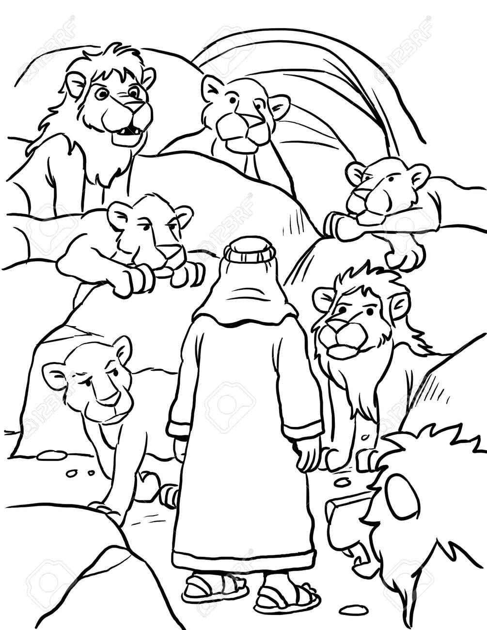

**Daniel**

**Cambridge Causeway**

Summer 2024

Bible Study notes

**Heroes of the Bible Part 2**

**4. Daniel and the lions**

By Chrissy Cole